Project Design Phase-II
Data Flow Diagram & User Stories

Date | 31 January 2025
Team ID
Project Name | Predictive Pulse – Hypertension Prediction System
Maximum Marks | 4 Marks

Data Flow Diagrams:
A Data Flow Diagram (DFD) is a traditional visual representation of the information flows within a system. A neat and clear DFD can depict the right amount of the system requirement graphically. It shows how data enters and leaves the system, what changes the information, and where data is stored.

Example: (Simplified)
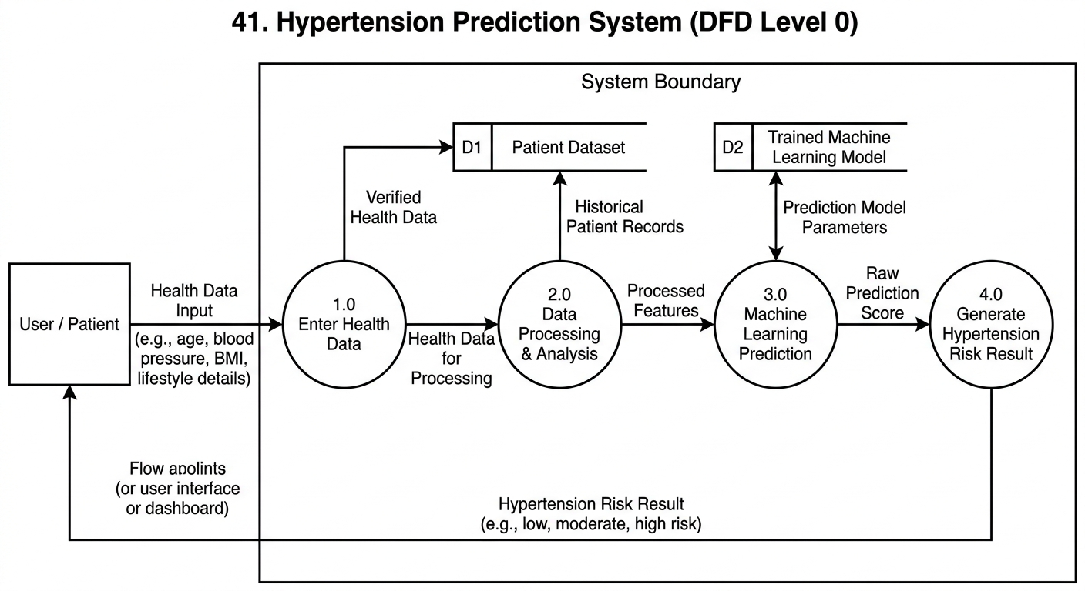

User Stories
Use the below template to list all the user stories for the product.
User Type | Functional  Requirement  (Epic) | User Story  Number | User Story / Task | Acceptance criteria | Priority | Release
Customer (Web User) | Data Input | USN-1 | As a user, I can enter my health details such as age, blood pressure, and lifestyle data | User can submit health data successfully | High | Sprint-1
Customer (Web User) | Prediction | USN-2 | As a user, I can receive hypertension prediction result | System shows prediction result after data submission | High | Sprint-2
Customer (Web User) | Risk Analysis | USN-3 | As a user, I can view hypertension risk level | Risk level displayed clearly on dashboard | High | Sprint-2
Customer (Web User) | Recommendations | USN-4 | As a user, I can receive lifestyle recommendations based on prediction | System suggests lifestyle changes | Medium | Sprint-3
Customer (Web User) | Dashboard | USN-5 | As a user, I can view my prediction history | Dashboard displays previous results | High | Sprint-3
Administrator | Data Management | USN-6 | As an admin, I can manage dataset used for training | Admin can upload/update dataset | High | Sprint-1
Administrator | Model Management | USN-7 | As an admin, I can update machine learning model | Updated model can be deployed | Medium | Sprint-3
Customer Care Executive | Support | USN-8 | As a support staff, I can assist users with system issues | Support team can access help dashboard | Low | Sprint-4

